**Software Requirement Specification**

**For**

**Scenery Frame reservation service**

**NEKFA AUSTRLIA (PVT) LTD**

4th Floor, 131, W A D Ramanayake Mawatha, Colombo 02

Tel: 011 2375062| email: info@nekfa.com

www.nekfa.com

|  |  |
| --- | --- |
| Deliverable | Software Requirement Specification- Scenery Frame reservation |
| Deliverable Date |  |
| Client | Negombo Municipal Council |

**Document Acceptance**

NEKFA Australia (PVT) LTD

|  |  |
| --- | --- |
| Name and Designation | Signature |
|  |  |
|  |  |

Document Amendment Register

|  |  |  |
| --- | --- | --- |
| Date | Author | Reviewer |
|  |  |  |
|  |  |  |

**Table of content**

**Table of Content**

**1. Introduction**

**1.1 Purpose -------------------------------------------------------------------------- 6**

**1.2 Intendant Audience and users -------------------------------------------------------- 6**

**1.3 Scope of Project ----------------------------------------------------------------- 6**

**1.4 References -------------------------------------------------------------------------- 6**

**2. Overall description**

**2.1 Product Perspective ----------------------------------------------------------------- 7**

**2.2 User classes and characteristics ----------------------------------------------- 7**

**2.3 Operating Environment -------------------------------------------------------- 8**

**2.4 Product features ----------------------------------------------------------------- 9**

**3. System Features**

**3.2 Request cemetery service --------------------------------------------------------**

**3.2.1 Flow chart ----------------------------------------------------------------- 11**

**3.2.2 Description ----------------------------------------------------------------- 11**

**3.2.3 Stimulus/Responses -------------------------------------------------------- 13**

**3.2.4 Functional requirements -------------------------------------------------------- 13**

**3.3 View booking payment details -----------------------------------------------**

**3.3.1 Flow chart ----------------------------------------------------------------- 14 3.3.2 Description ----------------------------------------------------------------- 14**

**3.3.3 Stimulus/Responses -------------------------------------------------------- 14**

**3.3.4 Functional requirements -------------------------------------------------------- 15**

**3.4 Pay for booked service 3**

**.4.1 Flow chart ----------------------------------------------------------------- 15**

**3.4.2 Description ----------------------------------------------------------------- 15**

**3.4.3 Stimulus/Responses -------------------------------------------------------- 15**

**3.4.4 Functional requirements -------------------------------------------------------- 16**

**3.5 Admin login**

**3.5.1 Flow chart -------------------------------------------------------------------------- 16**

**3.5.2 Description ----------------------------------------------------------------- 16**

**3.5.3 Stimulus/Responses -------------------------------------------------------- 17**

**3.5.4 Functional requirements -------------------------------------------------------- 17**

**INTRODUCTION**

**Purpose**

This document describes the Software Requirements Specification for the Rajapakshe garden scenery frame Reservation .The Purpose of this document is to provide guidelines for the development of the Garden scenery frame Reservation Portal.

**Scope of the project**

The Scope of this SRS document is to define the functional requirements for Rajapakshe garden scenery frame reservation of Negombo municipal council and its component like User management. It also defines user interfaces, user characteristics, sitemap, navigation etc. for the portal.

It also covers the non-functional requirements like performance, reliability, availability, security, maintainability etc.

The proposed system will facilitate the introduction of a new solution that could enhance and improve the service standards offered to the customer. The Purpose of this document is to provide guidelines for the development of the garden reservation system.

**Intendant audience and Users**

This project is a prototype for the Scenery Frame reservation of Rajapakshe garden online platform, that user can reserve the service through online. This project need to save customer-sensitive information and this has been implemented under the guidance of council members.

**References**

1. **OVERALL DESCRIPTION**

**2.1 PRODUCT PERSPECTIVE**

**2.2 USER CLASSES AND CHARACTERISTICS**

**Customer**

**Admin**

**2.3 OPERATING ENVIRONMENT**

The entire set of applications is built on technologies to ensure product performance and durability. The following technologies and software are used to develop the application.

* OS –Windows
* Database – MYSQL
* Platform Language – HTML/CSS/JS/PHP/C#

**3. SYSTEM FEATURES**

**3.1. REQUEST RESERVATION**

**Scenario:** Request Reservation

**Actor:** Customer

**Precondition: 1.** User should have internet connection

**3.1.1 Flow chart**

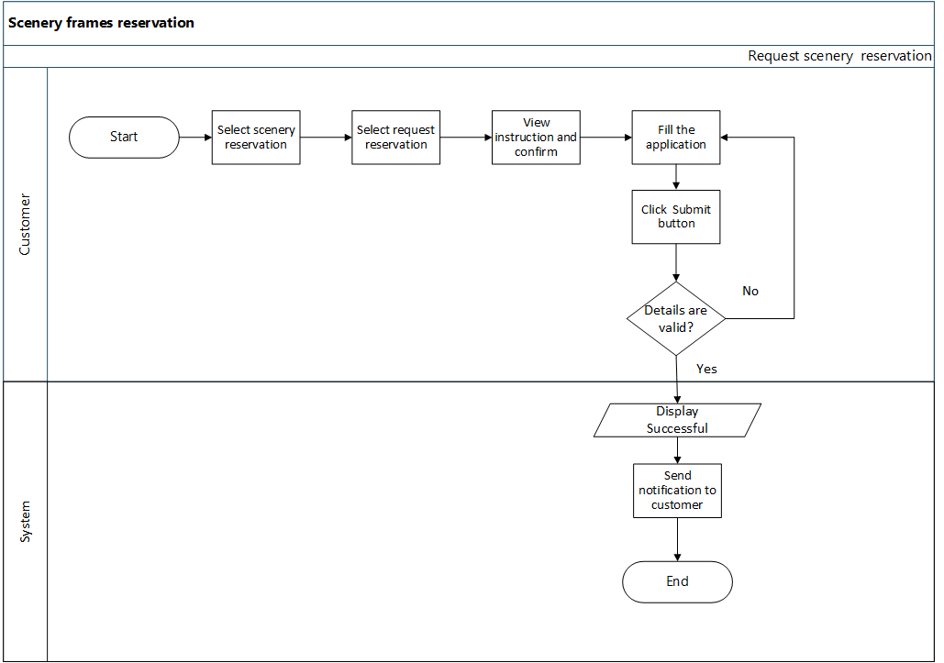

**3.1.2 Describe**

* Customer clicks the request reservation option and open the application instruction page. In this page have described the instruction of reservation and system will facilitate customer to confirm it*. (Wire frame -Figure1 .Figure2, Figure3,Figure 4)*
* Then customer direct in to the application page for garden scenery frame reservation section. Following details are required and consist in the customer application.

|  |  |  |  |  |
| --- | --- | --- | --- | --- |
| **Field** | **Field Type** | **Length** | **Priority** | **Comment** |
| Applicant name | Text field | 50 | Mandatory | * Can be Alphanumeric, Alphabetic value |
| Applicant NIC | Text field | 10 | Mandatory | * Can be Alphanumeric, Alphabetic value * Validate NIC format |
| Applicant address | Text field | 100 | Mandatory | * Can be Alphanumeric, Alphabetic value |
| Applicant mobile Number | Numeric | 10 | Mandatory | * Should auto fill with customer default phone number. * Should be numeric value. * Show tooltip. |
| Applicant Email | Text field |  | Optional | * Should validate email address |
| Reservation date | Date/Time |  | Mandatory | * User shall be able to select multiple dates. * Use grid for show selected date and time from(am / pm) -To(related time for each selected date ) * Use delete button to remove date by one inside the grid. * Use “Confirm” button to “add” button can add more dates. |
| Reservation Time |
| Reason | Text field | 225 | Mandatory | * User can describe the need of reason.(Text area) |
| Deposit amount | Numeric |  | Mandatory | * Should not be null value for “Total deposit amount”. * Use label or non- editable text field to show calculation. |
| NIC upload |  |  | Mandatory | * “Upload “button can open file ------- can select png, jpeg, PDF files types. |
| In the council | Drop down menu |  | Mandatory | * Use drop down |

* If user select more than one date according to the each date user will be able to select time duration for each date.
* After each field data entered, customer can Submit, Clear or pending request list of the application.
* **Submit application**

Customer filled after the application successfully who can submit the application by click the “Submit” icon and before the submit application, customer have to verify the submit (“reCAPCHA”). When submit completed the system will notification to the admin Or admin’s dash board in that time and submit completed, system required to send acknowledgment SMS notification to the customer.

* **Clear Application.**

If customer want to clear the filled details the in the application customer can click “Clear” icon.

* **Go Back**

If customer click “Back” button customer direct in to the user dashboard.

**Error flow.**

* If the user has not entered the required field data and submit, the system displays an error message for each field.
* User should have enter a valid NIC number.
* User should have enter a valid mobile number ex.07XXXXXXXX.

**3.1.3 Stimulus/ Responses**

**Stimulus**: User clicks the scenery reservation option.

**Response:** The system display user dashboard.

**Stimulus:** The user clicks the request reservation option.

**Response:** The system display instruction page with instruction.

**Stimulus:** The user view the instruction and click confirm check box.

**Response:** The system display “Application for Scenery Reservation”.

**Stimulus:** The user fill the application form and clicks submit icon.

**Response:** The system display “Successful” notification, Send notification to the admin as new request and receive notification to the customer mobile phone as about successfully submission of application.

**Stimulus:** If user fill the application and clicks clear icon.

**Response:** System display the empty input field with application.

**Stimulus:** If user fill the application and click Back button.

**Response:** The system direct in to the customer dashboard.

**3.1.4 Functional requirements**

**REQ - 1:** Customer shall be able to view instructions.

**REQ - 2:** Customer shall be able to fill application.

**REQ - 3:** Customer shall be able to submit the application.

**REQ - 4:** Customer shall be able to clear the application.

**REQ - 5:** Customer shall be able to go back to customer dashboard.

**REQ - 6:** System shall be able to send notification to customer.

**3.2.PAY FOR RESERVATION**

**Scenario** Pay for reservation

**Actor** Customer

**Precondition 1.**User should have internet connection

**2.** User should have submit the application

**3.** Admin should have updated (approved) the payment.

In this scenario, user can pay for reservation service after being approved by the admin**.**

**3.2.1Flow chart**

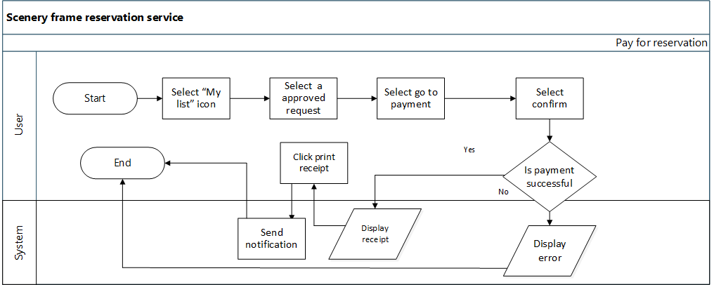

**3.2.3Description**

After admin approved and updated the payment user can pay for the reservation (*Figure 1*, *Figure 5*). Customer clicks the confirm pay and pay total amount using debit or credit card. *(Figure 6*)

When the payment is successful customer can print the receipt and also in the same time system send the notification to the customer.

**Following details are include in the receipt.**

* Oder id(Auto generated)
* Applicant Name
* Pay date
* Total fee
* Bank fee
* Total paid amount
* Pay by
* Reference Number

**Following details are consist on the approved details form view.**

* Applicant name
* Deposit Amount
* Applicant’s address
* Applicant’s mobile number
* Applicant’s NIC
* Park
* Requested dates
* In the council

**3.2.3 Stimulus/ Response**

**1. Stimulus:** User select “My list” option.

**Response:** System display list of request.

**2. Stimulus:** User click an admin approved request details.

**Response:** System display over view of approved details.

1**. Stimulus:** User clicks the Go to pay button.

**Response:** System displays a description of payment.

**1.1 Stimulus:** User clicks the confirm button.

**Response:** System check payment success or unsuccessful.

* + 1. **Stimulus:** If successful user clicks the receipt print button.
    2. **Stimulus**: If unsuccessful system display an error message.

**3. Stimulus:** User clicks the Back button.

**Response:** System goes to the My list page.

**Error flow**

* If payment is unsuccessful system display an error message.

**3.2.4 Functional Requirement**

**REQ-1:** User shall be able to view **payment approved details for the reservation service.**

**REQ-2: User shall be able to make payment.**

**REQ-3: User shall be able to confirm payment.**

**REQ-3: User shall be able to print payment.**

**REQ-3: System shall be able to send notification to customer.**

**3.3VIEW REJECTED RESERVATION DETAILS**

**Scenario**  Customer views rejected reservation details.

**Actor**  Customer

**Precondition:** **1**. User should have a web browser.

**2**. User should have an internet connection.

**3.** User should have requested reservation service.

**4.** Admin should have rejected the reservation.

**Flow chart**

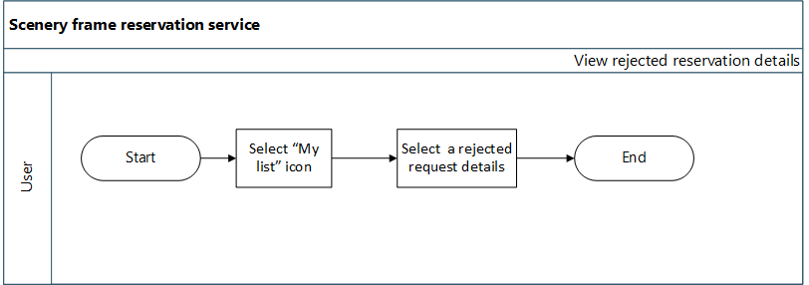

**Description**

When admin rejected the customer request the customer can view details of the reason for reject also system not will give the option for payment furthermore. *(Figure 7)*Following details are include in the customer rejected view.

* Applicant name
* Applicant’s address
* Applicant’s mobile number
* Applicant’s NIC
* Park
* requested dates
* Deposit Amount

**Error flow**

* The system displays an error message if the admin has not approved (rejected).

**3.3.3 Stimulus/ Responses**

1. **Stimulus:** The user selects a rejected request option.

**Response:** The system displays details of rejection.

**3.4.4 Functional Requirement**

**REQ-1:** The user shall be able to view the request list.

**REQ-2:** The user shall be able to view rejected reservation details.

**REQ-3:** The user shall not be able to give option to customer to update payment.

**VIEW PAID RESERVATION DETAILS**

**Scenario**  Customer views paid reservation details.

**Actor**  Customer

**Precondition:** **1**. User should have a web browser.

**2**. User should have an internet connection.

**3.** User should have requested reservation service.

**4**. Admin should have approved the reservation.

**5.** User should have paid for the reservation.

**Flow chart**

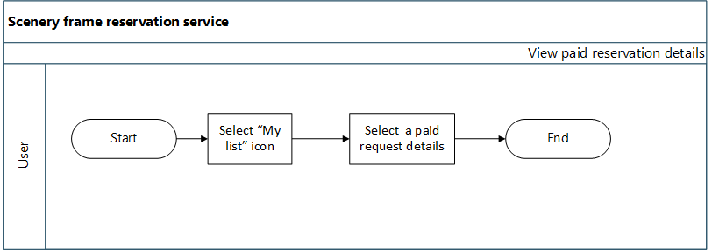

**Description**

When customer paid the payment for reservation that details are view in the paid list view*. (Figure 9)*

* Applicant name
* Applicant’s address
* Applicant’s mobile number
* Applicant’s NIC
* Park
* requested dates
* Deposit Amount

**Stimulus/ Responses**

**Stimulus:** The user selects a paid request details.

**Response:** The system displays details of paid.

**Functional Requirement**

**REQ-1:** The user shall be able to view the paid reservation details.

**VIEW REQUEST LIST DETAILS**

**Scenario** Admin view a pending reservation request list details.

**Actor** Admin

**Precondition 1**. User should have a web browser.

**2**. User should have an internet connection.

**3.** User should have requested service.

**3.6.1 Flow chart**

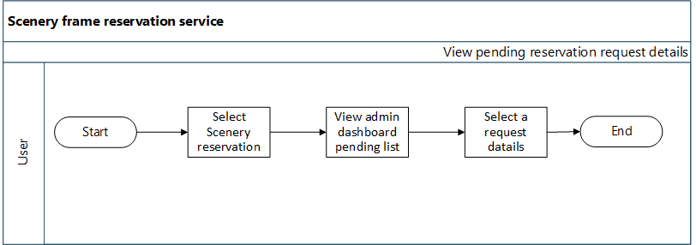

**Description**

After the customer request the reservation, the admin can view that details through pending request details. The system displays the request details of the applicant. So the system allows to admin to download attachments, go back to the pending details page of admin dashboard view, and print details options. After validating the request details admin can approve or reject the requested service. Also, the system sends messages to users through mobile numbers or email states of reject or approval*. (Figure 10)*

Admin should be able to do the following functionality

* Download and view NIC copy.
* Back
* Print request details
* Approve
* Reject

**Stimulate/response**

**Stimulus:** Admin clicks pending request details.

**Response:** The system display request details and history details.

**Stimulus:** Admin clicks the download icon.

**Response:** System display give option to the download attachment.

**Stimulus:** Admin clicks the print button.

**Response:** The system operates the print option.

**Stimulus:** Admin clicks the back button.

**Response:** System direct request pending list overview.

**Stimulus:** Admin click approves button.

**Response:**  The system display update payment form. (Explained in update payment)

**Stimulus:** Admin click the rejects button.

**Response:** System updates the request into rejected list overview and send a message to the Customer.

**Functional Requirement**

**REQ-1:** Admin shall be able to view pending request list details.

**REQ-2:** Admin shall be able to download and view NIC copy

**REQ-4:** Admin shall be able to go back pending request details.

**REQ-5:** Admin shall be able to print request details.

**REQ-6:** Admin shall be able to approve the valid request.

**REQ-7:** Admin shall be able to reject invalid request.

**REQ-8:** System shall be able to send notifications to the user, and states of request approval or rejection.

**ADMIN UPDATE PAYMENT.**

**Scenario** Admin update payment.

**Actor** Admin

**Precondition 1.** Admin should have internet connection.

**2**. User should have requested service.

**3**. Admin should have approved request.

**Flow chart**

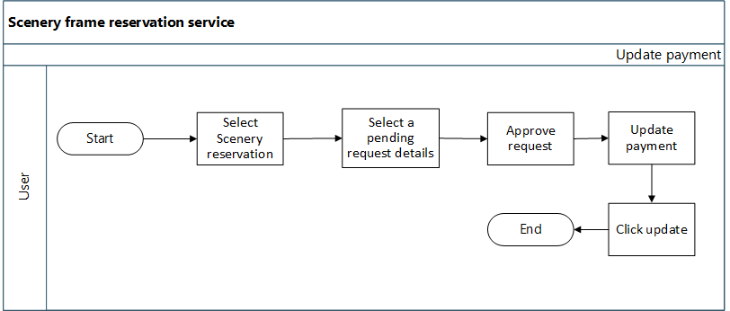

**Description**

After admin approved the application, system displays the update payment view. After update the total amount system will send notification to the customer and the updated request move in to the approved list view. Following details are include the approve request page.

* Requested Date/Dates
* List of selected dates and time.
* In the council?
* Payment Due date (admin can select date using calendar)
* Deposit Amount
* 1st Date charge (default Rs.10000.00)
* Additional date charges should calculate for additional details. Additional charge for one day is rs.5000.00 (admin can enter amount of additional payment)
* Total Deposit Amount( auto calculate the 1st Date charge + Additional date charges)
* Comments

**Stimulus/ Responses**

**Stimulus:** Admin enter amount of additional date charge

**Response:** System generate and display total deposit amount.

**Stimulus:** Admin enter update button.

**Response:** System display notification state of update success.

**Stimulus:** If user fill the application and clicks clear icon.

**Response:** System display the empty input field with application.

**Stimulus:** If user fill the application and click Back button.

**Response:** The system direct in to the admin dashboard.

**Functional requirements**

**REQ-1:** Admin shall be able to update payment.

**REQ-2:** Admin shall be able add due date.

**REQ-3:** Admin shall be able to select a due date.

**REQ-4:** system shall calculate additional date charges

**REQ-5:** admin shall able to edit additional charges

**REQ-6:** admin shall not be able to edit total deposit amount

**REQ-7:** System shall be able to generate total amount.

**REQ-8:** System shall be able to send notification to the customer.

**VIEW APPROVED REQUEST DETAILS**

**Scenario** View approved request list details.

**Actor** Admin

**Precondition**  **1**.Admin should have internet connection.

**2.** User should have requested service.

**3.** Admin should have approved the request.

**3.7.1Flowchart**

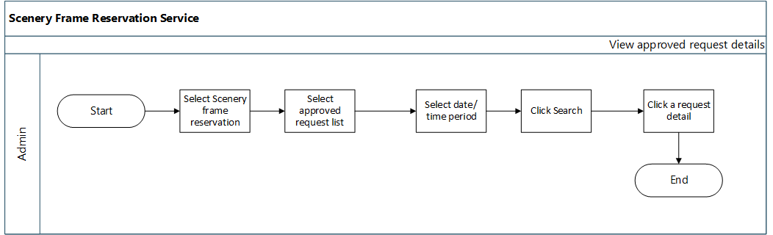

**3.7.2 Description**

After the approved reservation service request which request is moved into the approved request list view. Admin can select a particular time period and search list according to that time period. Also, system fetch the result user searched.

**3.7.3 Stimulus /Responses**

**Stimulus:** Admin select scenery reservation.

**Response:** System display dashboard overview of requesting list details.

**Stimulus:** Admin select the approved list option.

**Response:** System display the list of approved.

**Stimulus:** Admin select particular time duration and search.

**Response:** System displays the calendar to select the date and the filter result is display the details in the view.

**Functional Requirements**

**REQ-1:** Admin shall be able to select the time period for the filter list.

**REQ-2:** Admin shall be able to search a list of details in the selected time period.

**REQ-3:** System shall be able to display a calendar to select dates.

**REQ-4:** System shall be able to fetch the approved requested details list according to the selected date.

**3.8 VIEW PAID LIST DETAILS**

**3.8.1 Flow chart**

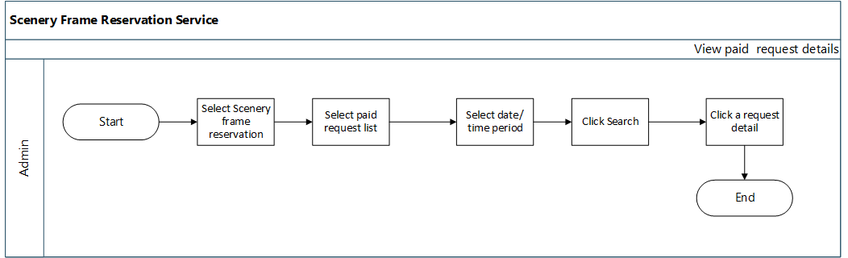

**3.4.2 Description**

**Scenario** View paid request details list

**Actor** Admin

**Precondition**

**1**. Admin should have internet connection.

1. User should have requested scenery frame reservation.

**3**. Admin should have approved user requests.

**4**. User should have paid for the service.

After the approved and updated payment request list details is moved into the paid request list. Admin can select a particular time period and search list according to that time period.

**3.8.3. Stimulus/Response**

**1. Stimulus:** Admin select paid request list icon.

**Response:** System display an overview of the paid request list.

1. **Stimulus:**  Admin selects time period search.

**Response:** System displays the calendar and fetches paid request list details to the view.

1. **Stimulus:** Admin selects a paid request.

**Response** System display details of paid list details.

**4. Stimulus:** Admin clicks the Back button.

**Response:** System direct cemetery request overview.

**Functional Requirement**

**REQ-1:** Admin shall be able to view paid request details.

**REQ-4:** Admin shall be able to go back cemetery service overview.

**REQ-3:** System shall be able to display a calendar to select dates.

**REQ-4:** System shall be able to fetch paid requested details list according to the selected date.

* 1. **VIEW REJECTED LIST DETAILS**

**3.9.1 Flow chart**

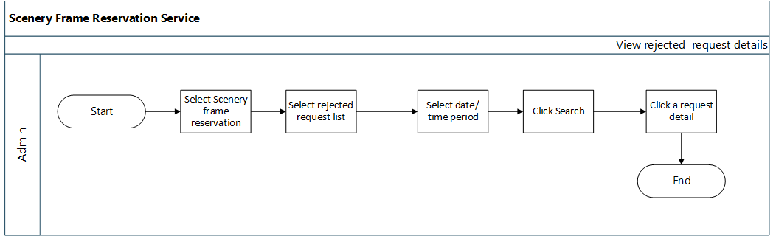

**3.9.2 Description**

**Scenario** Admin view rejected request details.

**Actor** Admin

**Precondition 1**. Admin should have internet connection.

**2.** User should have requested a Scenery reservation request.

**3**. Admin should have rejected the requested service.

After rejecting the request by admin that request move into the reject list section. Admin can select the date duration and the search system displays the rejected list details. Admin selects a request and who can view details overview of request details. Also,

**Stimulus/Responses**

**1. Stimulus:** Admin select rejected request list icon.

**Response:** System display an overview of the rejected request list.

**2. Stimulus:**  Admin select time period search.

**Response:** System display a calendar and fetch rejected request list details to the view.

1. **Stimulus:** Admin select a rejected request.

**Response:** System display details of rejected list details.

**4. Stimulus:** Admin click the Back button.

**Response:** System direct pending list page over view.

**Functional Requirement**

**REQ-1:** Admin shall be able to view rejected request list details.

**REQ-2**: Admin shall be able to select date duration and search.

**REQ-3:** Admin shall be able to view request details and history details.

**REQ-5:** Admin shall be able to print rejected request details.

**REQ-6:** Admin shall be able to go back cemetery service overview.

**REQ-7:** System shall be able to display a calendar to select dates.

**REQ-8:** System shall be able to fetch rejected requested details list according to the selected date.

EXTERNAL INTERFACE REQUIREMENT

**User Interfaces**

Web based Graphical User Interface (GUI) will be provided. Garden reservation Portal will be completely menu driven and user friendly. Portal will be designed so that with minimum number of clicks user should be able to access desired information. Screens will be ergonomically designed. Wherever possible, input fields will be pre-selected.

Product function wise user interfaces such as screen formats for Input forms, output screens, report layouts, menu structures have been explained in subsequent sections.

**Hardware Interfaces**

Users of the Rajapaksha Garden Reservation Portal will be able to access on their client systems, smart phones.

To host the portal, hardware servers will be required for Portal server (Content Management), Application Server, Database, SMS server with adequate back up facilities and disaster recovery mechanism for 24 X 7 availability.

**Software Interfaces**

User will be able to access the portal using web browser on the system having base Operating System. On Server end, in addition to base Operating system, software will be required for internet server, Content Management, Database.

NON-FUNCTIONAL REQUIREMENT

**Software Systems Attributes**

**Availability**

Availability refers to a system or component that is continuously operational for a desirably long length of time. It is an ability to withstand failure of individual components. Central Agricultural portal should be highly available. To make garden reservation solution to be highly available, it is essential that all components like hardware, network, system software, and application software for Garden reservation solution are operational all the time. If the system is not available for all the time, user loses his interest and avoids using the service again presuming that it may waste his/her time in accessing the service without any result.

**Scalability**

Scalability is the ability of a system, network, or process, to handle growing amount of load in a capable manner by means of deploying additional resources, if required, without any noticeable degradation of its performance.

**Usability**

Usability is a quality attribute that assesses how easy user interfaces are to use. Compromising user friendliness leads to loss of productivity. Garden Reservation Portal should be easy to use. The underlying technology should be transparent to users, so they can concentrate on tasks at hand. Screens should be designed for ease of use by non-technical users who do not have any computer knowledge. The GUI design shall be intuitive and task-based without any superfluous design

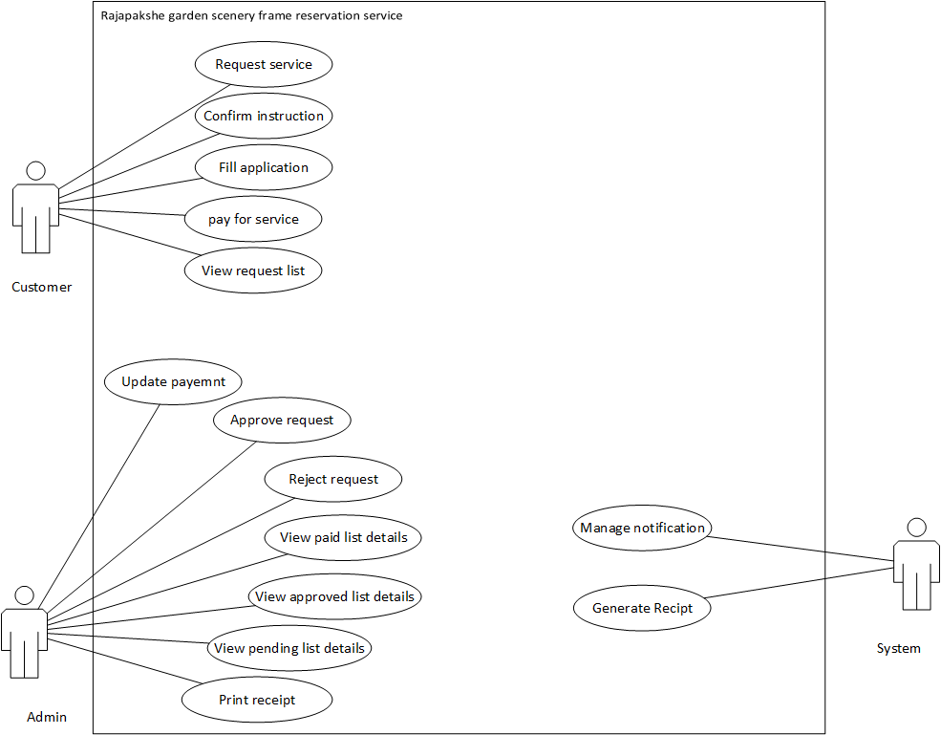

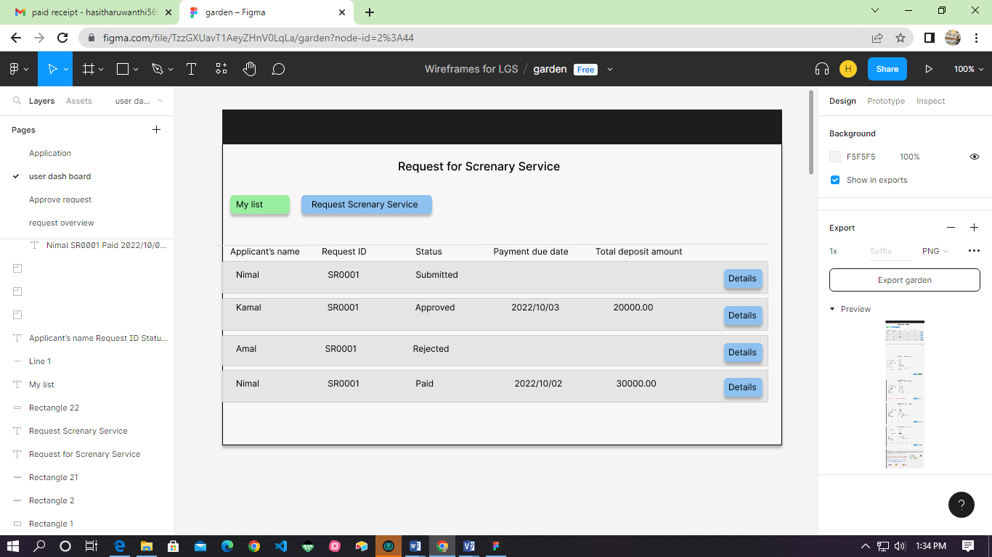

Figure 1-My list over view

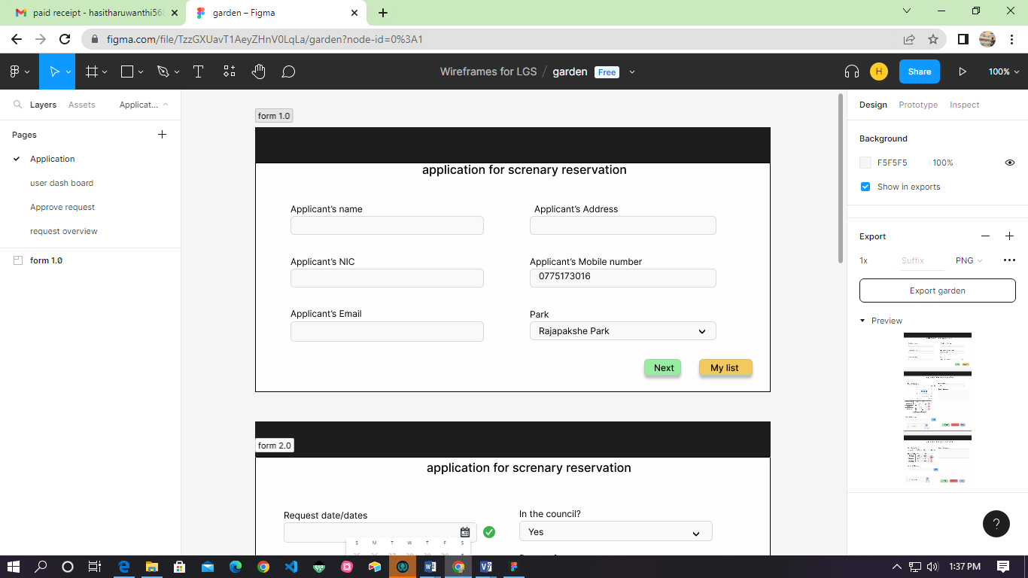

Figure 2-Application for reservation

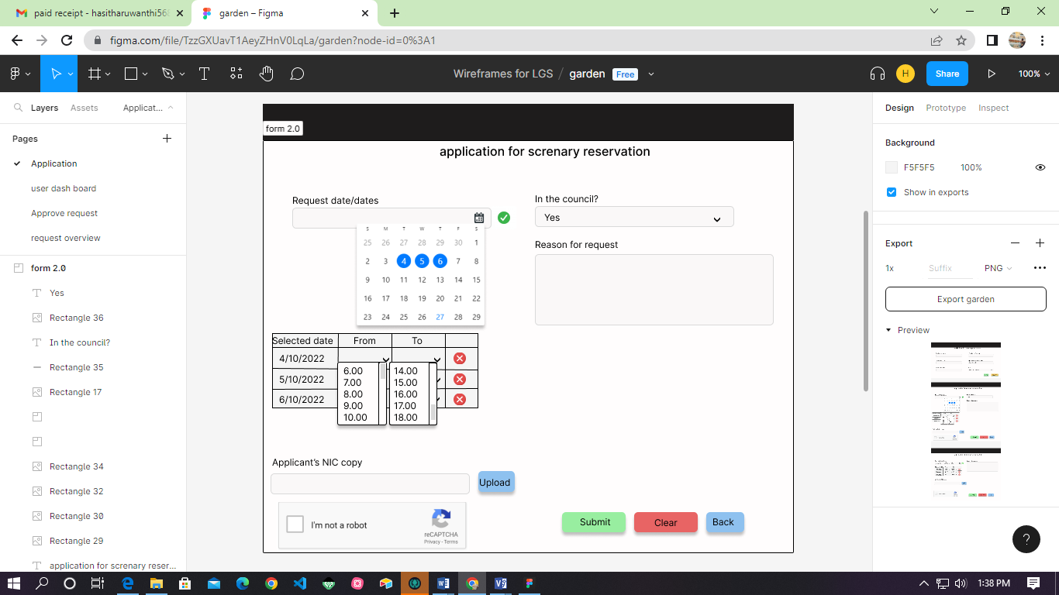

Figure 3- Application for reservation

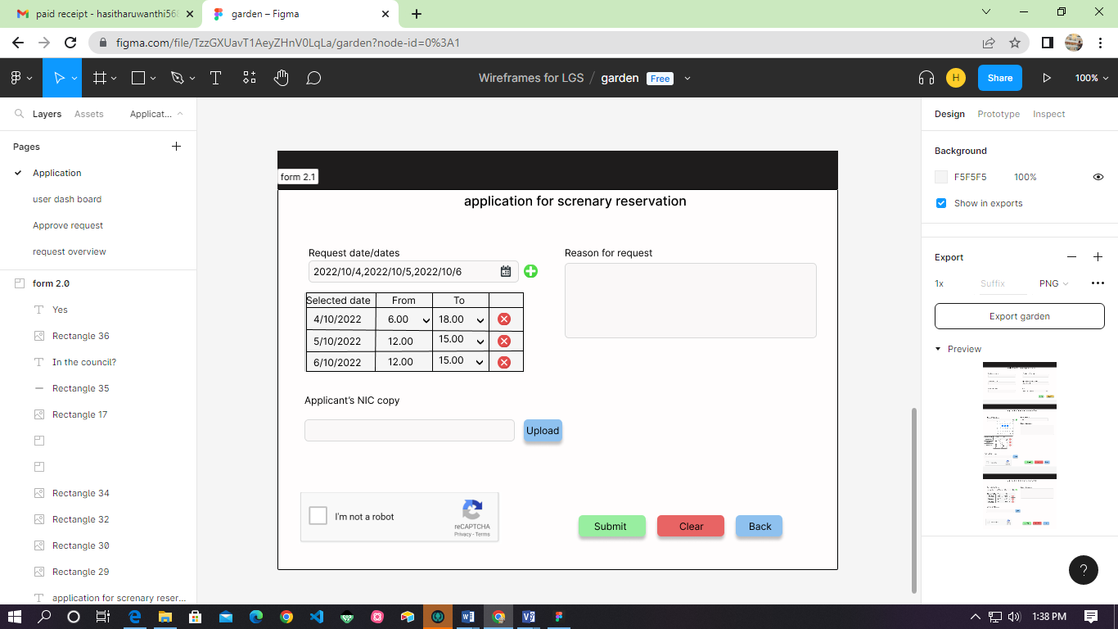

Figure 4- Application for reservation

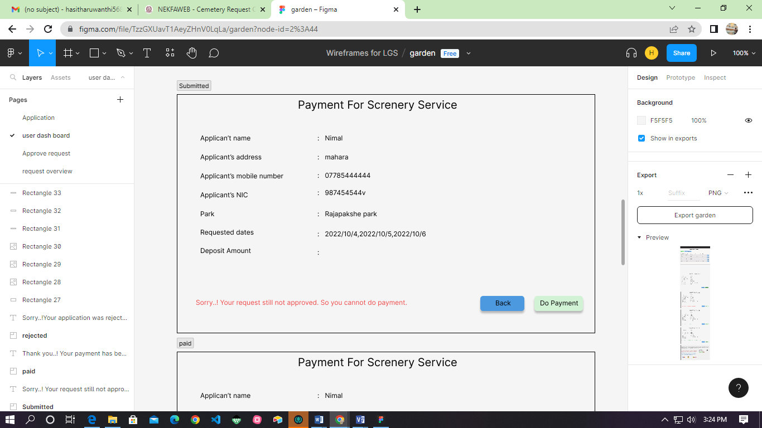

Figure 5- Submitted reservation request

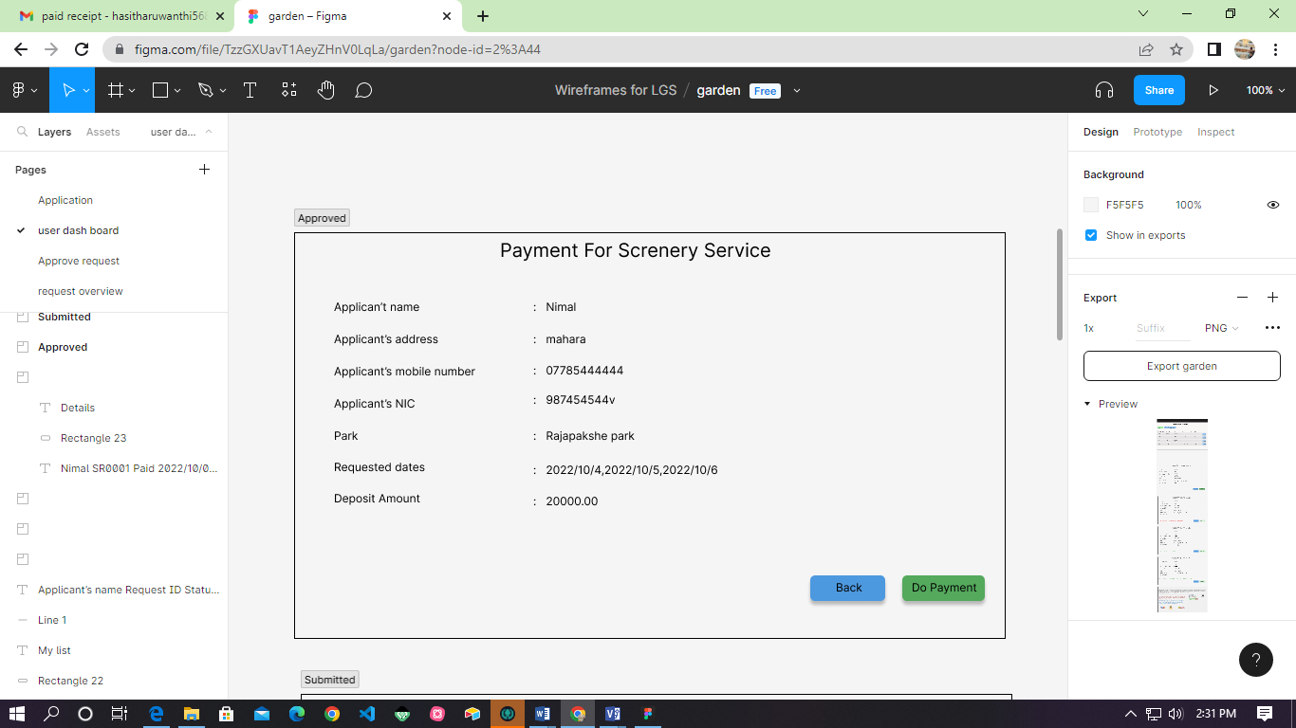

Figure 6-Approved request customer view

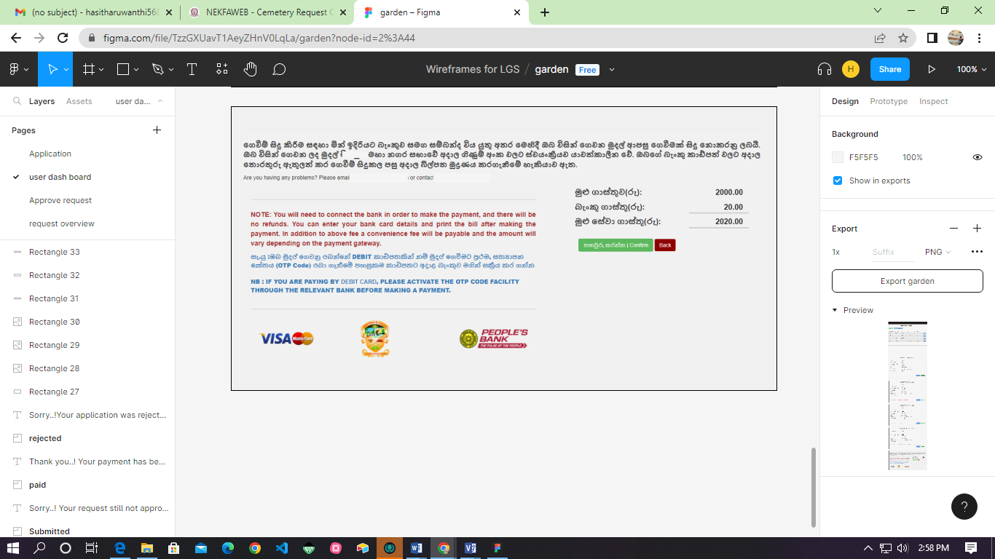

Figure 7-Make payment

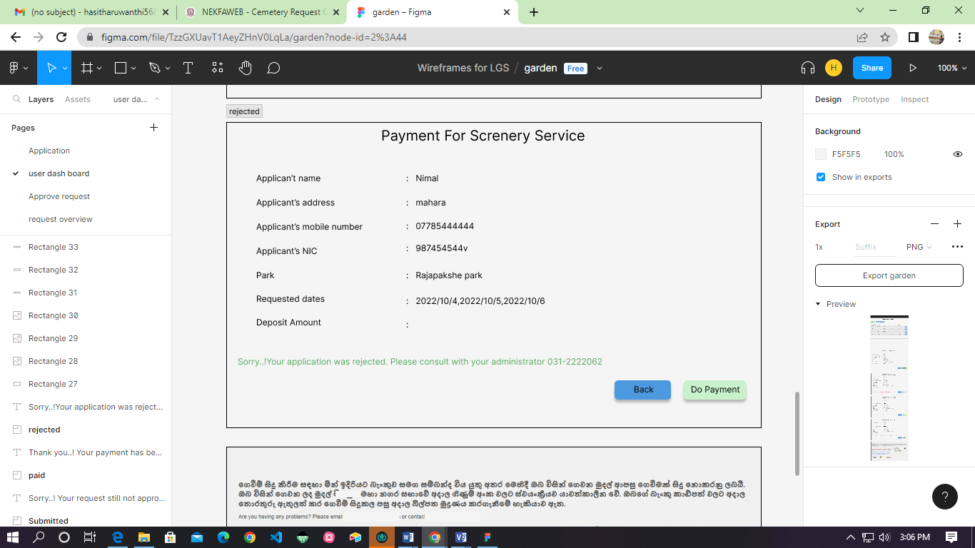

Figure 8-Rejected reservation request

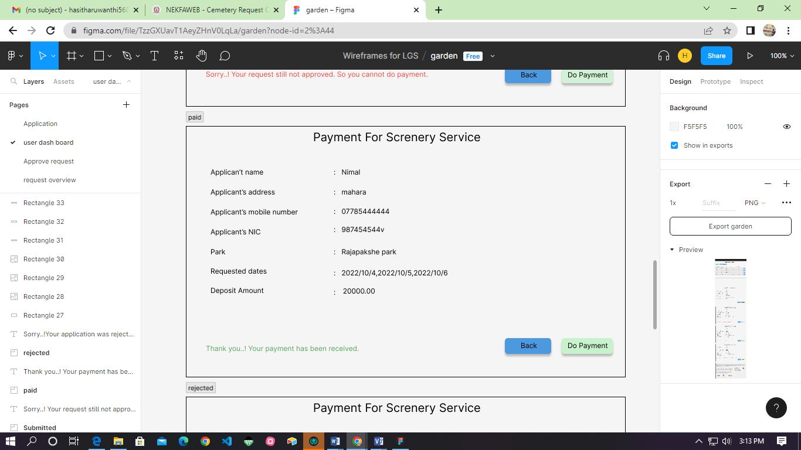

Figure 9- Paid reservation request

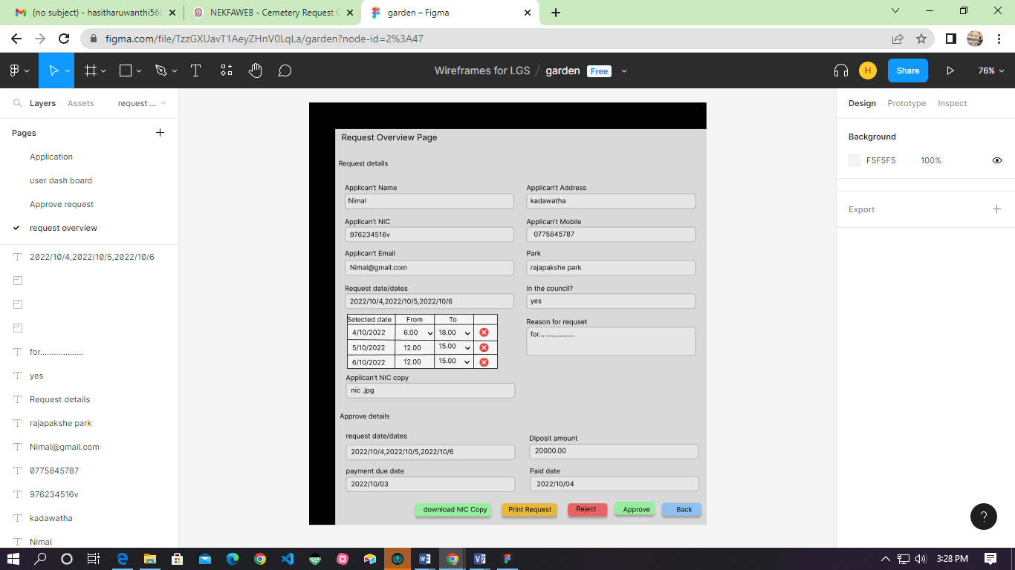

Figure 10- Request overview